**LAB 3**

**Exercise:**

**1. Encrypt the text “SH IS HE RX RY LO VE SH EA TH LE DG ER “with a key K= SHERRY what is the result?**

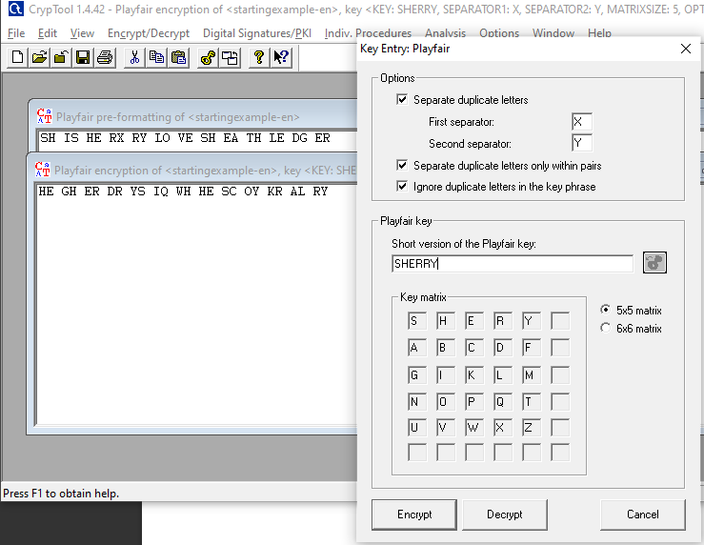

**2.Encrypt and Decrypt your name as a text and NED as a key using Playfair cipher and show the steps involved? Verify the answer using Cryptool.**

